**THEORY:**

Answer 1. Only the second kernel is separable as the rows of the kernel are multiple of each other, meaning the rank of the kernel is 1, for the other one the rank is 2

The 1-D component of 1st matrix cannot be broken into its 1-D component

The 1-D component of 2nd matrix are

A=[ -1] B=[1 3 1], where A*B=[-1 3 -1]

[ 0] [0 0 0]

[ 1] [1 3 1]

Function: The first one is an outline kernel to highlight large differences in pixel values. A pixel next to neighbor pixels with close to the same intensity will appear black while one next to neighbor pixels that differ strongly will appear white.

The second is a horizontal edge detection kernel to show only the differences in adjacent pixel values in a horizontal direction.

Answer 2. 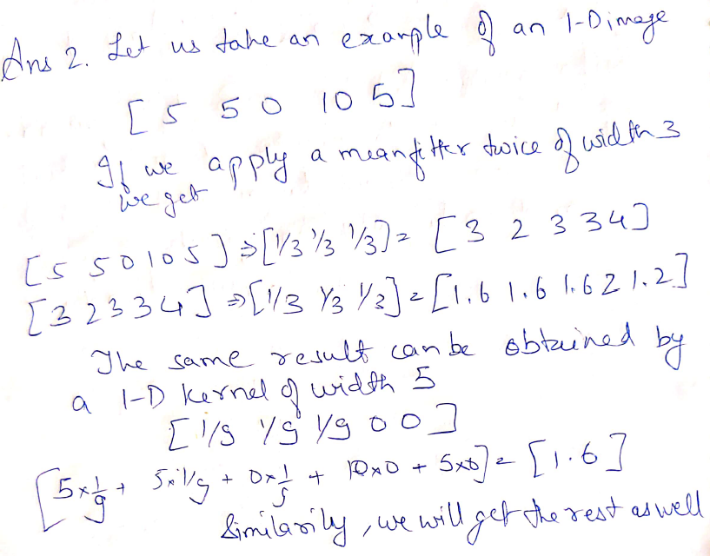

Answer 3. 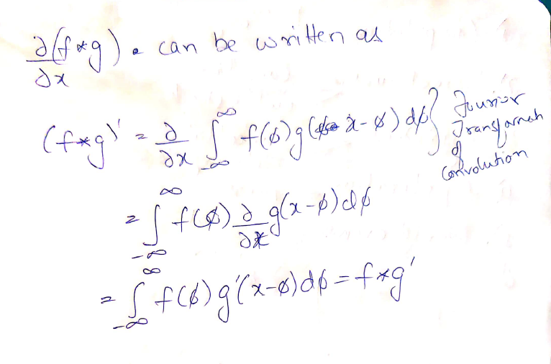

Answer 4. 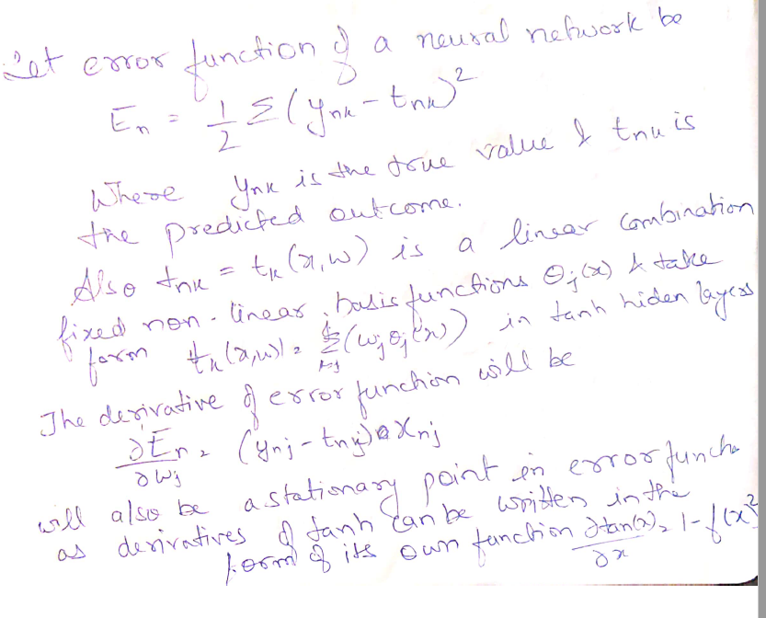

**Programming**

Answer 1 (a). Please check Assignment_1(a).ipynb report

Answer 1 (b) to 1(e). Please check Assignment_1(b_e).ipynb report

Answer 2(a)(i). There are 6 convolution layers, the filter size and number of filters at each layers are as follows,

conv layer filter size no. of filters

1 3x3 32

2 3x3 64

3 3x3 64

4 3x3 32

5 3x3 3

6 3x3 3

(ii). Code in colour regression.ipynb

Original, 6 layers and 25 epochs

Epoch [25/25], Loss: 0.0083

Epoch [25/25], Val Loss: 0.0080

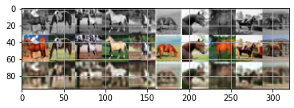

7 Layers, 50 epochs

Epoch [50/50], Loss: 0.0074

Epoch [50/50], Val Loss: 0.0072

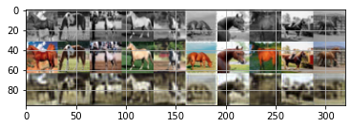

7 layers, 10 epochs

Epoch [10/10], Loss: 0.0109

Epoch [10/10], Val Loss: 0.0107

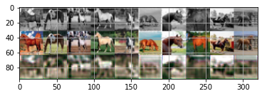

7 layers, 100 epochs

Epoch [100/100], Loss: 0.0060

Epoch [100/100], Val Loss: 0.0062

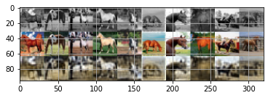

Layer 7 epochs:1000

Epoch [1000/1000], Loss: 0.0040

Epoch [1000/1000], Val Loss: 0.0083

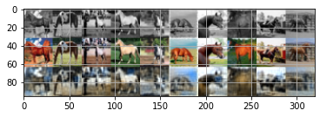

As epochs are increased the total loss keeps on decreasing and validation loss becomes stuck at 0.06. Visually the image looks much sharper at higher epochs but the color saturation is still poor. At 1000 epochs, color blue starts to become more prominent but validation loss increased slightly as it tries to over fit blue

(iii). RGB doesn’t provide the details on the depth of the colors like hue and saturation which human eyes are able to determine

(iv). Squared error would try to over fit the data in cases of outliers, which would not become the If the target variable is a label instead of a continuous variable

Answer 2(b) 1. Jupyter notebook (colourization.ipynb)

Answer 2(b) (ii) The output is more contrasting especially the white and blacks but the colors seem much more faded and some of the pictures are not even recognizable. It also was much slower to each epoch than the previous model. The loses are also quite high in validation

Epoch [25/25], Loss: 1.7353, Time (s): 64

Epoch [25/25], Val Loss: 1.7303, Val Acc: 36.3%, Time(s): 65

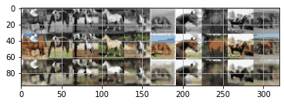

Answer 2(c). (i) The execution was a lot faster as max pooling reduced the complexity of calculating relu function by reducing the image input dimensions without affecting much validation loss

Epoch [25/25], Loss: 1.7284, Time (s): 30

Epoch [25/25], Val Loss: 1.7086, Val Acc: 37.7%, Time(s): 30

Answer 2(c) (ii). Human Eyes sees the whole picture and assess the difference between two images. Per pixel loss only sees the individual pixel errors and doesn’t take into account how similar the images look visually. The best way to capture that is to take squared mean error instead of absolute in order to involve all the pixels so that picture is compared as a whole. This is also called perceptual loss function.